Following is a summary of the 1999 K1209 10 meter data used to create the CAP88 meteorological data file.

Statistics from k10999.asc file:

avg avg data # hrs
speed T rec. good
m/s degF rate data
---- ----- ---- ----
1.4 58.0 98.3 8615

Stability Distribution:

(stability determined by SRDT method)

S perc.
- -----
A 5.0
B 16.8
C 8.4
D 22.0
E 7.5
F 40.4
G 0.0

Number of Good Hours of Data by Day of the Month:

mo 1 2 3 4 5 6 7 8 9 10 11 12 13 14 15 16 17 18 19 20 21 22 23 24 25 26 27 28 29 30 31
-- -- -- -- -- -- -- -- -- -- -- -- -- -- -- -- -- -- -- -- -- -- -- -- -- -- -- -- -- -- -- --
1 24 23 24 24 24 24 24 24 22 24 24 24 24 24 24 24 24 24 24 24 24 24 24 24 24 24 24 24 24 24 24
2 24 24 24 24 23 24 24 24 24 24 24 24 24 24 24 24 24 23 24 18 21 24 24 24 24 24 24 24
3 24 24 24 23 24 24 22 24 24 23 23 24 24 24 24 24 24 24 24 24 24 24 20 24 24 24 20 24 25 24 24
4 24 24 24 20 24 24 24 24 24 24 24 24 24 24 24 24 24 24 24 24 24 24 24 24 24 24 24 24 24 23
5 24 24 24 24 24 23 24 24 24 24 24 24 24 23 24 24 24 24 23 24 24 24 24 24 24 24 23 24 24 24 24
6 24 24 24 24 24 24 24 24 24 24 24 24 24 24 24 24 21 24 24 23 24 23 24 24 24 24 24 24 12 23
7 23 24 24 24 24 17 17 24 24 16 0 14 24 24 24 24 24 24 24 24 24 23 24 24 24 24 23 24 24 24 24
8 24 24 24 24 24 24 24 24 24 24 24 24 24 24 23 24 24 23 24 23 24 24 23 24 24 24 23 24 24 23 24
9 24 24 24 24 23 23 24 24 24 24 24 24 24 23 24 23 24 24 24 24 24 23 24 24 24 24 24 24 24 24
10 24 24 24 24 23 24 24 24 24 24 24 24 24 24 24 24 23 24 24 24 24 24 24 24 24 24 24 24 24 24 24
11 24 23 24 24 24 24 24 24 24 24 23 24 24 24 24 22 24 24 24 24 24 24 24 24 24 24 24 24 23 24
12 24 24 24 24 24 24 23 24 24 24 23 24 24 24 24 22 24 24 23 24 24 15 24 24 24 24 24 24 24 24 23

Data Recovery Rate
by Month of the Year

mo rate
%
-- -----
1 99.6
2 98.4
3 98.4
4 99.3
5 99.5
6 97.5
7 92.1
8 99.2
9 99.3
10 99.7
11 99.3
12 98.0

Average Temperature (degF) by Day of the Month

mo 1 2 3 4 5 6 7 8 9 10 11 12 13 14 15 16 17 18 19 20 21 22 23 24 25 26 27 28 29 30 31
---- ---- ---- ---- ---- ---- ---- ---- ---- ---- ---- ---- ---- ---- ---- ---- ---- ---- ---- ---- ---- ---- ---- ---- ---- ---- ---- ---- ---- ---- ----
1 31.5 39.3 27.6 20.0 19.2 25.9 37.6 43.1 34.7 26.5 30.7 41.7 49.0 49.1 34.8 38.2 39.6 50.3 39.9 50.3 55.9 65.9 61.7 44.3 42.1 43.0 50.0 55.1 53.1 51.8 45.0
2 43.5 47.4 43.4 48.6 41.2 45.1 55.8 48.1 51.6 55.2 60.4 42.8 30.5 29.6 36.6 45.6 48.6 42.7 40.7 42.2 32.2 29.0 36.7 34.8 39.8 41.5 43.6 48.2
3 42.0 45.3 39.6 34.3 43.0 48.3 38.2 38.4 39.7 38.6 36.8 39.3 37.4 42.8 38.7 43.2 52.0 54.9 47.3 51.6 53.0 45.2 51.6 52.8 46.3 41.8 47.5 47.6 51.0 52.0 49.4
4 57.6 58.5 65.3 73.7 66.1 65.5 67.1 63.0 75.4 68.0 74.1 54.2 53.2 54.1 56.0 53.1 47.8 48.9 54.2 61.0 63.1 66.3 69.6 66.1 62.7 61.7 63.9 64.1 52.4 54.1
5 57.5 58.9 60.6 64.4 63.9 66.4 64.6 63.4 64.5 67.9 69.8 69.3 65.1 64.1 63.2 67.3 69.0 66.9 64.3 63.8 66.7 71.3 67.0 65.3 65.5 63.9 61.6 63.1 67.3 72.3 70.2
6 72.7 70.5 73.0 72.4 70.8 75.0 75.1 76.1 77.9 75.5 75.7 76.0 76.3 69.9 73.2 70.7 68.8 65.8 67.7 68.6 71.7 72.7 73.7 72.1 74.7 74.6 74.9 78.0 69.7 67.4
7 75.2 76.4 78.5 79.7 80.8 80.4 79.2 78.1 76.1 74.9 0.0 67.1 69.2 72.5 73.8 75.8 75.6 76.6 76.0 77.1 75.9 77.0 80.3 75.9 77.1 79.6 78.8 77.4 80.3 81.4 82.8
8 80.8 78.4 75.0 74.3 75.3 74.1 74.6 73.8 76.3 75.3 77.2 79.3 81.4 75.8 72.8 77.1 79.3 78.2 78.2 73.6 71.3 71.9 70.2 73.8 75.2 73.9 72.4 75.2 75.4 71.6 70.3
9 70.3 71.3 73.4 73.7 74.4 75.6 75.7 73.4 72.0 66.8 66.8 71.8 68.5 69.6 68.0 64.0 60.8 62.1 67.1 66.8 59.5 54.5 55.0 59.9 62.4 65.0 71.6 73.0 67.3 54.7
10 55.1 58.1 60.6 64.8 55.2 55.7 58.8 61.8 63.4 67.9 67.2 67.3 64.1 60.4 58.4 59.8 61.0 56.5 52.3 53.0 46.7 53.7 47.3 42.7 43.1 47.4 52.4 53.8 54.9 56.4 60.9
11 61.7 51.0 41.2 40.7 46.3 51.9 57.5 60.0 57.7 57.6 60.5 53.8 53.4 58.1 47.2 41.0 39.9 40.7 47.3 54.6 56.3 55.9 57.2 55.4 52.8 48.1 40.7 46.7 43.4 35.2
12 32.8 36.7 41.9 49.8 49.8 41.7 34.7 39.2 47.6 51.3 44.1 47.8 56.7 46.8 41.0 39.2 37.6 42.3 49.5 50.0 35.3 34.8 32.7 30.3 24.9 33.6 35.5 35.2 38.6 36.5 43.6

Stability Distribution by Hour of the Day

hr A B C D E F G
---- ---- ---- ---- ---- ---- ---- ----
1 0 0 0 30 44 286 0
2 0 0 0 34 36 288 0
3 0 0 0 25 47 287 0
4 0 0 0 29 50 277 0
5 0 0 0 29 57 272 0
6 0 0 0 33 54 270 0
7 0 0 0 137 40 181 0
8 0 0 0 248 21 90 0
9 0 106 8 247 0 0 0
10 0 204 44 110 0 0 0
11 13 192 70 82 0 0 0
12 81 156 57 66 0 0 0
13 93 150 62 55 0 0 0
14 96 133 78 54 0 0 0
15 70 143 89 58 0 0 0
16 56 124 94 84 0 0 0
17 25 106 86 142 0 0 0
18 0 73 85 114 28 57 0
19 0 60 47 90 33 128 0
20 0 0 0 69 73 216 0
21 0 0 0 46 46 270 0
22 0 0 0 39 38 283 0
23 0 0 0 40 33 288 0
24 0 0 0 33 43 284 0

Following is a wind rose of the 1999 K1209 10 meter data.

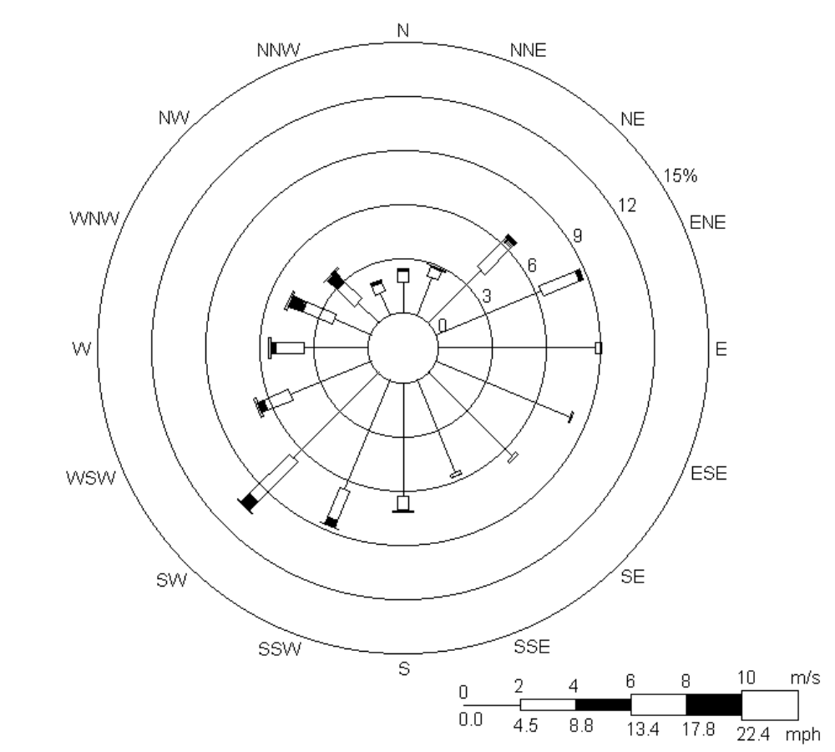

Following is a wind rose for CAP88/PC with adjustment for calm winds, i.e. calms are distributed in the first wind class in proportion to the sum of the frequencies of observations occurring in the first two wind speed classes.

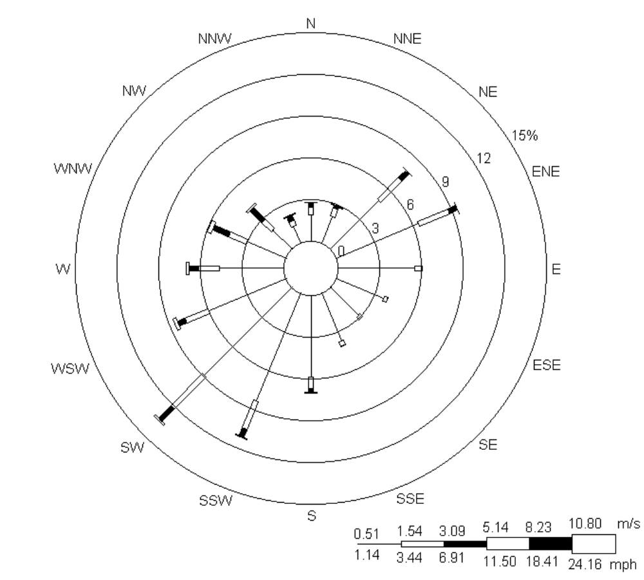

Following is a wind rose from the STAR file with the modified wind speed classes.

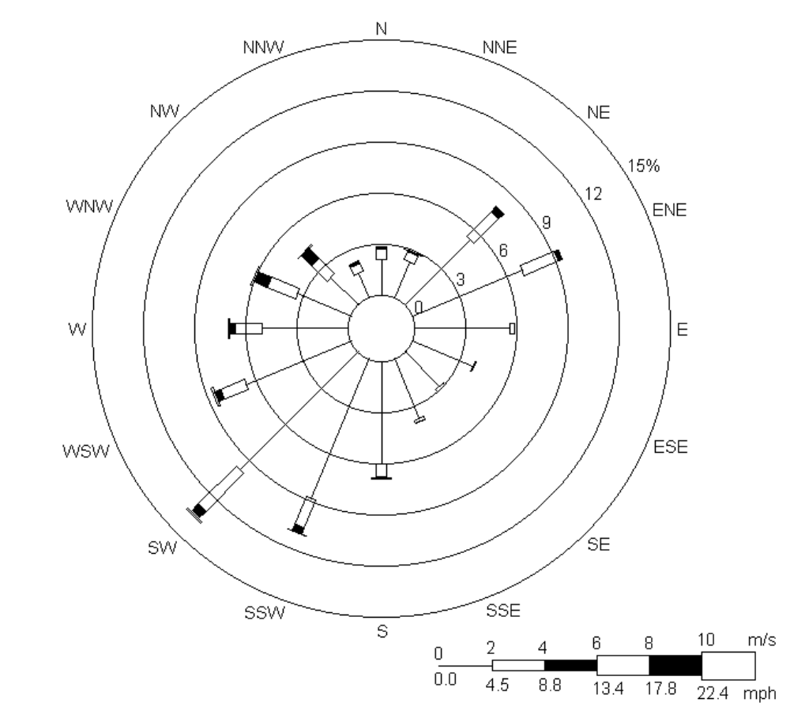

Following is a listing of the CAP88/PC meteorological data file (.str file).

N A 0.000580.000460.000000.000000.000000.00000
NNE A 0.000930.000350.000000.000000.000000.00000
NE A 0.001160.001040.000000.000000.000000.00000
ENE A 0.001040.001040.000000.000000.000000.00000
E A 0.001740.000700.000000.000000.000000.00000
ESE A 0.001280.000700.000000.000000.000000.00000
SE A 0.002090.000230.000000.000000.000000.00000
SSE A 0.002780.000700.000000.000000.000000.00000
S A 0.005800.001040.000000.000000.000000.00000
SSW A 0.006030.001510.000000.000000.000000.00000
SW A 0.007540.001390.000000.000000.000000.00000
WSW A 0.003710.001740.000000.000000.000000.00000
W A 0.001620.000460.000000.000000.000000.00000
WNW A 0.001160.000120.000000.000000.000000.00000
NW A 0.000580.000230.000000.000000.000000.00000
NNW A 0.000230.000350.000000.000000.000000.00000
N B 0.003010.000580.000120.000000.000000.00000
NNE B 0.003250.001510.000230.000000.000000.00000
NE B 0.005680.004990.004060.000000.000000.00000
ENE B 0.007310.004410.001620.000000.000000.00000
E B 0.006730.002090.000000.000000.000000.00000
ESE B 0.005220.001390.000000.000000.000000.00000
SE B 0.003940.000000.000000.000000.000000.00000
SSE B 0.004870.000700.000000.000000.000000.00000
S B 0.009040.001740.000350.000000.000000.00000
SSW B 0.016350.005570.001510.000000.000000.00000
SW B 0.017390.006380.001280.000000.000000.00000
WSW B 0.012640.004410.001040.000000.000000.00000
W B 0.010900.003360.000930.000000.000000.00000
WNW B 0.003360.001510.001040.000000.000000.00000
NW B 0.002780.000700.000700.000000.000000.00000
NNW B 0.002440.000230.000460.000000.000000.00000
N C 0.000000.001160.001280.000000.000000.00000
NNE C 0.000000.001390.001040.000000.000000.00000
NE C 0.000000.006840.002440.000230.000000.00000
ENE C 0.000000.004870.002200.000230.000000.00000
E C 0.000000.001510.000000.000000.000000.00000
ESE C 0.000000.000350.000120.000000.000000.00000
SE C 0.000000.000700.000000.000000.000000.00000
SSE C 0.000000.000230.000000.000000.000000.00000
S C 0.000000.001970.001160.000000.000000.00000
SSW C 0.000000.006730.002320.000230.000000.00000
SW C 0.000000.012180.007190.000350.000000.00000
WSW C 0.000000.004750.001970.000120.000000.00000
W C 0.000000.003360.002550.000230.000000.00000
WNW C 0.000000.001970.003130.000120.000000.00000
NW C 0.000000.001970.004060.000000.000000.00000
NNW C 0.000000.001040.001390.000120.000000.00000
N D 0.004170.002440.001860.000230.000000.00000
NNE D 0.003480.001860.000350.000230.000000.00000
NE D 0.009280.006840.000930.000000.000000.00000
ENE D 0.009740.009510.002200.000000.000000.00000
E D 0.008460.001040.000120.000000.000000.00000
ESE D 0.003710.000350.000000.000000.000000.00000
SE D 0.004060.001040.000000.000000.000000.00000
SSE D 0.004640.001280.000120.000000.000000.00000
S D 0.006960.002440.000930.000580.000000.00000
SSW D 0.010320.005680.001970.000350.000000.00000
SW D 0.013450.009280.004060.001040.000000.00000
WSW D 0.008120.005100.002670.002550.000000.00000
W D 0.007540.005330.003360.001280.000000.00000
WNW D 0.005570.008000.008230.002670.000000.00000
NW D 0.004170.005220.007070.001510.000000.00000
NNW D 0.002670.001510.002090.000120.000000.00000
N E 0.002320.000700.000000.000000.000000.00000
NNE E 0.002200.000580.000000.000000.000000.00000
NE E 0.006030.001390.000000.000000.000000.00000
ENE E 0.006610.002550.000000.000000.000000.00000
E E 0.002780.000000.000000.000000.000000.00000
ESE E 0.002550.000000.000000.000000.000000.00000
SE E 0.000700.000350.000000.000000.000000.00000
SSE E 0.003250.000230.000000.000000.000000.00000
S E 0.004060.000700.000000.000000.000000.00000
SSW E 0.004750.001740.000000.000000.000000.00000
SW E 0.007420.001860.000000.000000.000000.00000
WSW E 0.004870.001280.000000.000000.000000.00000
W E 0.003250.002320.000000.000000.000000.00000
WNW E 0.003830.001740.000000.000000.000000.00000
NW E 0.002550.001280.000000.000000.000000.00000
NNW E 0.001040.000580.000000.000000.000000.00000
N F 0.009160.000120.000000.000000.000000.00000
NNE F 0.011250.000460.000000.000000.000000.00000
NE F 0.027710.000350.000000.000000.000000.00000
ENE F 0.039540.001160.000000.000000.000000.00000
E F 0.035130.000000.000000.000000.000000.00000
ESE F 0.024350.000000.000000.000000.000000.00000
SE F 0.017970.000000.000000.000000.000000.00000
SSE F 0.021800.000120.000000.000000.000000.00000
S F 0.033050.000230.000000.000000.000000.00000
SSW F 0.046150.000580.000000.000000.000000.00000
SW F 0.043720.000930.000000.000000.000000.00000
WSW F 0.031080.000460.000000.000000.000000.00000
W F 0.023420.000230.000000.000000.000000.00000
WNW F 0.016810.000230.000000.000000.000000.00000
NW F 0.009390.000350.000000.000000.000000.00000
NNW F 0.007310.000120.000000.000000.000000.00000
N G 0.000000.000000.000000.000000.000000.00000
NNE G 0.000000.000000.000000.000000.000000.00000
NE G 0.000000.000000.000000.000000.000000.00000
ENE G 0.000000.000000.000000.000000.000000.00000
E G 0.000000.000000.000000.000000.000000.00000
ESE G 0.000000.000000.000000.000000.000000.00000
SE G 0.000000.000000.000000.000000.000000.00000
SSE G 0.000000.000000.000000.000000.000000.00000
S G 0.000000.000000.000000.000000.000000.00000
SSW G 0.000000.000000.000000.000000.000000.00000
SW G 0.000000.000000.000000.000000.000000.00000
WSW G 0.000000.000000.000000.000000.000000.00000
W G 0.000000.000000.000000.000000.000000.00000
WNW G 0.000000.000000.000000.000000.000000.00000
NW G 0.000000.000000.000000.000000.000000.00000
NNW G 0.000000.000000.000000.000000.000000.00000

Following is the STAR file for AIRDOS/EPA.

0.001044 0.000000 0.000000 0.000000 0.000000 0.000000
0.001276 0.000000 0.000000 0.000000 0.000000 0.000000
0.001623 0.000580 0.000000 0.000000 0.000000 0.000000
0.001739 0.000348 0.000000 0.000000 0.000000 0.000000
0.002319 0.000116 0.000000 0.000000 0.000000 0.000000
0.001971 0.000000 0.000000 0.000000 0.000000 0.000000
0.002319 0.000000 0.000000 0.000000 0.000000 0.000000
0.003363 0.000116 0.000000 0.000000 0.000000 0.000000
0.006841 0.000000 0.000000 0.000000 0.000000 0.000000
0.007189 0.000348 0.000000 0.000000 0.000000 0.000000
0.008581 0.000348 0.000000 0.000000 0.000000 0.000000
0.005102 0.000348 0.000000 0.000000 0.000000 0.000000
0.001971 0.000116 0.000000 0.000000 0.000000 0.000000
0.001276 0.000000 0.000000 0.000000 0.000000 0.000000
0.000812 0.000000 0.000000 0.000000 0.000000 0.000000
0.000580 0.000000 0.000000 0.000000 0.000000 0.000000
0.003363 0.000464 0.000000 0.000000 0.000000 0.000000
0.003827 0.000928 0.000116 0.000000 0.000000 0.000000
0.007189 0.005334 0.002203 0.000000 0.000000 0.000000
0.008697 0.004058 0.000580 0.000000 0.000000 0.000000
0.007653 0.001044 0.000000 0.000000 0.000000 0.000000
0.006609 0.000000 0.000000 0.000000 0.000000 0.000000
0.003942 0.000000 0.000000 0.000000 0.000000 0.000000
0.004870 0.000580 0.000000 0.000000 0.000000 0.000000
0.009740 0.001276 0.000116 0.000000 0.000000 0.000000
0.018437 0.003711 0.001044 0.000000 0.000000 0.000000
0.020060 0.004522 0.000580 0.000000 0.000000 0.000000
0.015190 0.003131 0.000116 0.000000 0.000000 0.000000
0.011827 0.002667 0.000348 0.000000 0.000000 0.000000
0.003942 0.001623 0.000696 0.000000 0.000000 0.000000
0.002783 0.000928 0.000464 0.000000 0.000000 0.000000
0.002551 0.000232 0.000348 0.000000 0.000000 0.000000
0.000000 0.002087 0.000348 0.000000 0.000000 0.000000
0.000000 0.002319 0.000116 0.000000 0.000000 0.000000
0.000232 0.007537 0.001739 0.000000 0.000000 0.000000
0.000348 0.005566 0.001391 0.000000 0.000000 0.000000
0.000000 0.001507 0.000000 0.000000 0.000000 0.000000
0.000116 0.000348 0.000000 0.000000 0.000000 0.000000
0.000000 0.000696 0.000000 0.000000 0.000000 0.000000
0.000000 0.000232 0.000000 0.000000 0.000000 0.000000
0.000000 0.002783 0.000348 0.000000 0.000000 0.000000
0.000696 0.007305 0.001276 0.000000 0.000000 0.000000
0.000348 0.015886 0.003363 0.000116 0.000000 0.000000
0.000232 0.005798 0.000696 0.000116 0.000000 0.000000
0.000116 0.004754 0.001044 0.000232 0.000000 0.000000
0.000000 0.003479 0.001739 0.000000 0.000000 0.000000
0.000000 0.003479 0.002551 0.000000 0.000000 0.000000
0.000000 0.001739 0.000812 0.000000 0.000000 0.000000
0.004754 0.003131 0.000928 0.000000 0.000000 0.000000
0.003595 0.001739 0.000348 0.000116 0.000000 0.000000
0.010552 0.006030 0.000464 0.000000 0.000000 0.000000
0.010900 0.010088 0.000464 0.000000 0.000000 0.000000
0.008697 0.000696 0.000000 0.000000 0.000000 0.000000
0.003711 0.000232 0.000000 0.000000 0.000000 0.000000
0.003827 0.000928 0.000000 0.000000 0.000000 0.000000
0.005102 0.000696 0.000116 0.000000 0.000000 0.000000
0.007073 0.002899 0.000348 0.000580 0.000000 0.000000
0.011480 0.005102 0.001739 0.000116 0.000000 0.000000
0.015654 0.009508 0.002087 0.000696 0.000000 0.000000
0.009508 0.005334 0.002783 0.001160 0.000000 0.000000
0.008465 0.006378 0.001855 0.000812 0.000000 0.000000
0.006146 0.011248 0.005798 0.001276 0.000000 0.000000
0.004870 0.007885 0.005102 0.000232 0.000000 0.000000
0.003015 0.003015 0.000464 0.000000 0.000000 0.000000
0.002435 0.000580 0.000000 0.000000 0.000000 0.000000
0.002551 0.000232 0.000000 0.000000 0.000000 0.000000
0.006957 0.000928 0.000000 0.000000 0.000000 0.000000
0.007189 0.001507 0.000000 0.000000 0.000000 0.000000
0.002783 0.000000 0.000000 0.000000 0.000000 0.000000
0.002551 0.000000 0.000000 0.000000 0.000000 0.000000
0.000928 0.000116 0.000000 0.000000 0.000000 0.000000
0.003247 0.000116 0.000000 0.000000 0.000000 0.000000
0.004290 0.000580 0.000000 0.000000 0.000000 0.000000
0.005218 0.001276 0.000000 0.000000 0.000000 0.000000
0.008001 0.001160 0.000000 0.000000 0.000000 0.000000
0.005798 0.000464 0.000000 0.000000 0.000000 0.000000
0.003942 0.001623 0.000000 0.000000 0.000000 0.000000
0.004174 0.001391 0.000000 0.000000 0.000000 0.000000
0.002899 0.000928 0.000000 0.000000 0.000000 0.000000
0.001276 0.000348 0.000000 0.000000 0.000000 0.000000
0.009624 0.000000 0.000000 0.000000 0.000000 0.000000
0.011943 0.000000 0.000000 0.000000 0.000000 0.000000
0.027597 0.000000 0.000000 0.000000 0.000000 0.000000
0.041048 0.000000 0.000000 0.000000 0.000000 0.000000
0.034091 0.000000 0.000000 0.000000 0.000000 0.000000
0.023539 0.000000 0.000000 0.000000 0.000000 0.000000
0.017509 0.000000 0.000000 0.000000 0.000000 0.000000
0.021336 0.000000 0.000000 0.000000 0.000000 0.000000
0.032352 0.000000 0.000000 0.000000 0.000000 0.000000
0.045455 0.000000 0.000000 0.000000 0.000000 0.000000
0.045223 0.000000 0.000000 0.000000 0.000000 0.000000
0.030728 0.000000 0.000000 0.000000 0.000000 0.000000
0.024583 0.000000 0.000000 0.000000 0.000000 0.000000
0.018553 0.000000 0.000000 0.000000 0.000000 0.000000
0.011480 0.000000 0.000000 0.000000 0.000000 0.000000
0.008117 0.000000 0.000000 0.000000 0.000000 0.000000
0.000000 0.000000 0.000000 0.000000 0.000000 0.000000
0.000000 0.000000 0.000000 0.000000 0.000000 0.000000
0.000000 0.000000 0.000000 0.000000 0.000000 0.000000
0.000000 0.000000 0.000000 0.000000 0.000000 0.000000
0.000000 0.000000 0.000000 0.000000 0.000000 0.000000
0.000000 0.000000 0.000000 0.000000 0.000000 0.000000
0.000000 0.000000 0.000000 0.000000 0.000000 0.000000
0.000000 0.000000 0.000000 0.000000 0.000000 0.000000
0.000000 0.000000 0.000000 0.000000 0.000000 0.000000
0.000000 0.000000 0.000000 0.000000 0.000000 0.000000
0.000000 0.000000 0.000000 0.000000 0.000000 0.000000
0.000000 0.000000 0.000000 0.000000 0.000000 0.000000
0.000000 0.000000 0.000000 0.000000 0.000000 0.000000
0.000000 0.000000 0.000000 0.000000 0.000000 0.000000
0.000000 0.000000 0.000000 0.000000 0.000000 0.000000
0.000000 0.000000 0.000000 0.000000 0.000000 0.000000

